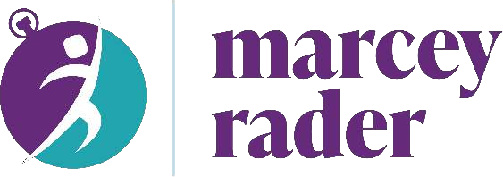

Introduction for engagement

Please print this page to read when introducing Marcey to the stage.

Marcey Rader believes that health powers productivity. As the founder of RaderCo, she helps executives and their teams banish burnout through practical tools and sustainable habits.

Marcey is a multi-certified health and productivity expert, a digital wellness practitioner, three-time author, has spoken on five continents, and is part of the 1% of speakers worldwide with the distinguished Certified Professional Speaker® designation.

Off-camera, Marcey is married to Kevin, a professional drummer and drum teacher. You can find her in Raleigh, North Carolina, doing walking meetings, drinking iced coffee, or relaxing in her infrared sauna.

Long Bio

Marcey Rader believes that health powers productivity. She's a multi-certified health, productivity, and digital wellness expert, award-winning global speaker, and 3-time author. As the founder of the comprehensive productivity company, RaderCo, she and her expert team help executives banish burnout and keep great employees through coaching, consulting, speaking, and training.

After her own corporate burnout triggered autoimmune disease, Marcey became a passionate advocate for valuing wellness in the workplace.

Sought after by Fortune 100 companies, startups, and everyone in-between, Marcey’s spoken for more than 100,000 people across five continents – from North Dakota to Dubai. Recognized as one of only 850 Certified Speaking Professionals® worldwide, she's a top 1% speaker who trains her audiences to improve their focus, maximize their energy, conquer the calendar, master tasks, and extinguish their email.

With her signature career-accelerating tool - the Powered Path Program™ - and powerful productivity book, "Work Well. Play More!", Marcey is well-known for giving people simple, tangible tools and practical steps to regain time and declutter the body and mind - one habit at a time.

Learn more or connect with Marcey at www.marceyrader.com.

Short bio

Marcey Rader believes that health powers productivity. She's a multi-certified health, productivity, and digital wellness expert, award-winning global speaker, and 3-time author. As the founder of the comprehensive productivity company, RaderCo, she and her expert team help executives banish burnout and keep great employees through coaching, consulting, speaking, and training.

Sought after by Fortune 100 companies, startups, and everyone in-between, Marcey’s spoken for more than 100,000 people across five continents – from North Dakota to Dubai. Recognized as one of only 850 Certified Speaking Professionals® worldwide, she's a top 1% speaker who trains her audiences to improve their focus, maximize their energy, conquer the calendar, master tasks, and extinguish their email.

To change your career, team, or organization one habit at a time, connect with Marcey at www.marceyrader.com.

2-sentence bio

Marcey Rader is a multi-certified health, productivity, and digital wellness expert, award-winning global speaker, creator of the Powered Path Program™, and 3-time author. As the founder of the comprehensive productivity company, RaderCo, she and her expert team help executives banish burnout and keep great employees through coaching, consulting, speaking, and training.

